**This Week at a Glance in Eighth Grade English Class**:

**\*\* Website:**  ***Check out our Teacher Websites for important notes and information***

**“A Sound of Thunder” Literature and** **Vocabulary Quiz 5/8**

**Monday, May 7, 2018**

**In Class:** Review for “A Sound of Thunder” Literature and Vocab Quiz

**Homework:** Study for “A Sound of Thunder” Literature and Vocab Quiz



**Tuesday, May 8, 2018**

**In Class:** “A Sound of Thunder” Literature and Vocab Quiz

**Homework:** Have a Great Time in Boston!

**Wednesday, May 9, 2018**

**In Class:** Boston Trip (Students not going should report to library)



**Homework:**

**Thursday, May 10, 2018**

**In Class:** Boston Trip (Students not going should report to library)

**Homework:**

**Friday, May 11, 2018**

**In Class:** The Ray Bradbury Theater Presents:“A Sound of Thunder”

**Homework:** Bring **Fully Charged** Chrome BookMonday for SRI

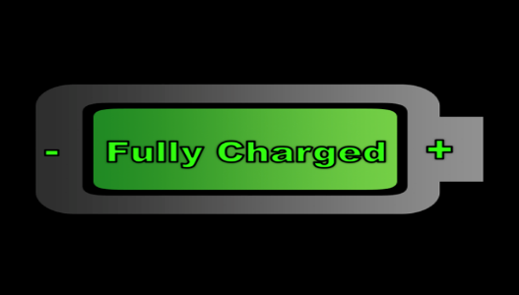

**Next Week: SRI…Sci-fi continued…and more!**

**Remember that this is a plan. As in life, things may change!**



.